ASIA PACIFIC INSTITUTE OF INFORMATION TECHNOLOGY
Level 4

COMP40004 WEB DEVELOPMENT AND OPERATING SYSTEMS

Individual Assignment 2 (Weightage 30%)

You are required to design and implement a simple web application which demonstrates the usage of proper web standards.

Learning Outcomes

Upon completion of this assignment, you will be expected to achieve the following learning outcomes:
- DESIGN, PROGRAM AND TEST A WEB APPLICATION USING CURRENT WEB STANDARDS, AND IN DOING SO, ADDRESS THE TARGET AUDIENCE AND DEVICE IN THE PROCESS SO THAT THIS WORKS EFFECTIVELY FOR MOBILE AND OFFLINE USE

Technical Requirements
The solution needs to be implemented using HTML and CSS with ONLY the external web libraries mentioned in the assignment.

Scenario

You have been asked to create a client-side web application for a Gaming Retailer. The need arose by the owner of the store. The application should address the needs of customers, providing a seamless experience across various devices. You need to show your skills in web development, including web design, creating pages with HTML, styling using CSS and testing web applications.
The application should be designed to showcase you and your skills, suitable to market yourself later to prospective employers.
The site map for the application is shown below:
Web Application

Home Page
About us and contact
Consoles and Gaming Peripherals

Games
Upcoming Games
Queries and FAQ

Assignment criteria

- Your whole application must:
- The site must be created using PURE HTML and CSS; NO template editors or generator tools can be used.
- NO External CSS and JavaScript libraries can be used for this assignment.
- Must have a minimum of 7 HTML pages and are not limited to:
  - Home page
  - About us page
  - Upcoming games
  - Consoles and Gaming Peripherals (This will direct user to “Consoles” and “Gaming Peripherals” pages)
  - Games
  - Queries and FAQs

- Your whole application must be a progressive web application and, therefore, must:
- Be hosted on HTTPS (GitHub Pages)
- Contain a web manifest with icon files
- Contains responsive images for different screen resolutions

- Your whole web application should be styled using ONLY CSS, ensuring that it:
- Suits for the target audience
- It is responsive on all pages from mobile devices to desktop devices. The website should be styled in a mobile first approach.
- No inline STYLES; all CSS should be in its own CSS files linked using the link tag
- Works on all modern browsers
- Shows the appropriate number of columns on mobile and desktop
- Shows responsive tables
- Shows how animation can help the user experience by providing items the user can interact with
- Shows your skills in DRY standards conformant CSS

- Each page must contain suitable and appropriate HTML for the following:
- Semantic HTML
- <header>, <main>, <footer> tags
- A navigation section with <nav> tags and appropriate links
- References of content as comments in the footer area
- Semantic tags for elements, sectioning, grouping, text and media

- The Home page must contain the following:
- A brief introduction about the Store.
- A suitable responsive main image
- Three sub-sections(with section tags), each having
  - A suitable image
  - At least two paragraphs of applicable content
  - Appropriate headings
- All the following items are somewhere on the page
  - A bullet point list of relevant content
  - A numbered list of relevant content
  - HTML comments for use by developers, which are not displayed on the page

- About us page must contain the following:
- Suitable content about different branches of the Store (each branch needs to have a name, a map, images, Opening, Closing hours and a description).
- A summary table showing relevant details for the store.
- The table must have (you can decide on the appropriate content for the table)
  - appropriate headings
  - at least three columns and at least three rows
  - a table footer

- Upcoming Games page will contain the following:

- Brief introduction about how the store is keeping up with upcoming new titles.
- Images of upcoming games arranged via a Flexbox.
- The user should be able to see the release date when hovered over the game image.
- Consoles and Gaming Peripherals page will contain the following:
- Descriptions of Consoles and Gaming Peripherals that are being sold in the store.
- Images of Consoles and gaming peripherals arranged via a Grid.
- The user should be able to see the price of an item when hovered over the image.

- Games Page
- The Games page should have all the games listed down in any way you prefer.
Example: 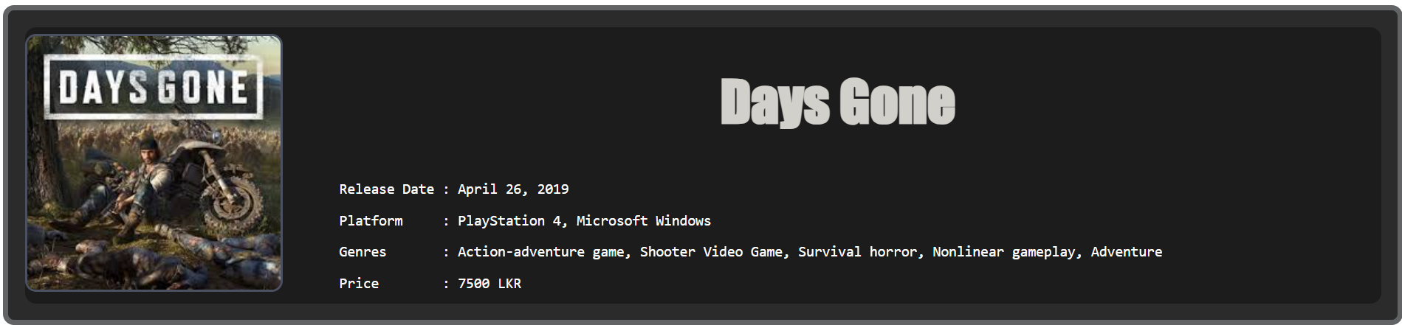
- When hovered over the image you should have a transition effect and show the description of the game.
Example:
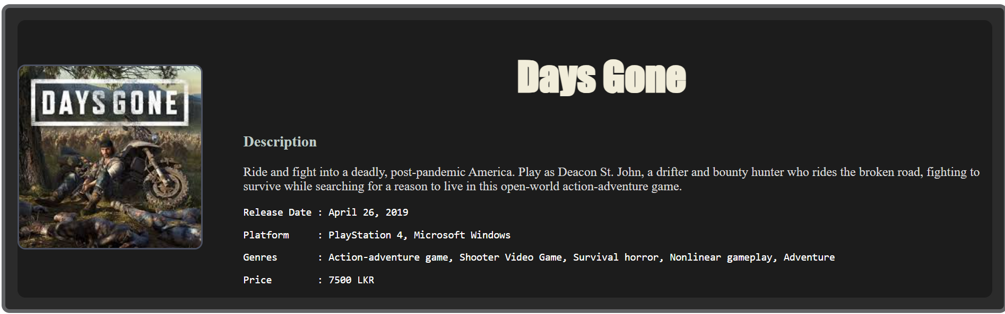

- Queries and FAQ page
- The top part of the page should have Frequently asked questions and answers for these questions
- The bottom part of the page should have a form which will help the user ask questions from the store owner
- The web application needs to be tested and proper tests cases should be generated for the following tests,
  - HTML validity
  - CSS validity
  - Accessibility using WAVE
  - Lighthouse testing
  - Responsiveness on different devices and browsers (3 devices, 3 browsers)

Resources to Refer

- HTML Linkedin Learning
- CSS Linkedin Learning
- Progressive Web Application (PWA)

Tasks

You will need to submit the following
A PDF documents
Your project folder
- Design your web application showing low-fidelity wireframes for all your pages in a desktop and mobile layout
- Build your web application as per the specifications shown above
- PDF document should contain the following
- A description states what you learned from this project, any challenges you faced, and how you overcame them.
  - Your wireframes for both desktop and mobile versions

Marking Criteria – Assignment 2
Task | Marks
Wireframe Report  - Suitable wireframes for both Desktop and mobile versions | 10
Application  - Compliance to requirements 5-10 | 30
Application – Progressive Web Application  - your conformance to the specification requirements 1-2  - your implementation of good quality, well-structured code | 10
Application – Site CSS  - your conformance to the specification requirements 3  - your implementation of good quality code  - your UI / UX skills for usability and design | 15
Testing Report  • HTML validity  • CSS validity  • Accessibility using WAVE  • Lighthouse testing  • Responsiveness on different devices and browsers | 15
Application - Overall discretionary mark  - your use of innovative approaches to the problem  - your demonstration of high-level coding skills  - robustness of the final web application  - your use of Semantic web technologies for SEO support | 10
Application demonstration and Q/A | 10
TOTAL | 100
Note: 30% is taken from the total as the final mark

Assignment 3 (Sem 2)
- The order page provides an ECMA Script application for buying computer parts from the website
- the interface should have suitable form elements to allow the customers to get the computer parts they want.:
- The webpage should have different sections such as:
  - Processors (6 or more)
  - Graphic Cards (6 or more)
  - Motherboards (6 or more)
  - Memory (RAM) (4 or more)
  - Storage Devices (6 or more)

  - The items are added as quantities
- There should be a table showing current items that were added and their price. The table should show the total price of all the items that were added.
- When the buy now button is clicked:
  - the user is navigated to a new page where they will be shown their order and will be asked to enter their personal details, delivery details and payment information.
- When the " Pay" button is clicked:
  - If all the fields are entered correctly a message is displayed thanking the user for their purchase. The message should include the delivery date.
- The order page should provide advanced features to:
- save an order as a favourite
  - 2 buttons need to be added to the interface
  - when the "add to favourites" button is clicked, the order should be saved in local storage, overwriting any existing favourite
  - when “Apply favourites” button is clicked. The form and the table should be filled with favourite items.
- The web application needs to be tested and proper tests cases should be generated for the following tests,
  - HTML validity
  - CSS validity
  - Accessibility using WAVE
  - Lighthouse testing
  - Responsiveness on different devices and browsers
  - Functional tests for your product reservation application

Tasks

You will need to hand in the following
A copy of PDF document containing activity diagrams and test results
A link to your web application online

A Design your web application showing activity diagrams for the application
B Build your purchase and donate page as per the specification shown above
C Test your web application and create a test table showing your tests for the following
  - HTML validity
  - CSS validity
  - Accessibility using WAVE
  - Lighthouse testing
  - Responsiveness on different devices and browsers
  - Functional tests for your computer parts ordering application
- Create a word document report and convert it to PDF which shows the following
  - Your designs in activity diagrams
  - Your test results in the form of a test table
  - A link to your web application which we will use to assess your application
  - Conclusion

Marking Criteria
Task | Marks
Report - Activity diagrams  - your activity diagrams for the order page | 10
Application – basic purchase  - your conformance to the specification requirements 11  - your implementation of good quality, well-structured code  - the efficiency of the code | 15
Application – advanced ordering features  - your conformance to the specification requirements 12  - your implementation of good quality, well-structured code  - the efficiency of the code | 10
Report / Application – Testing  - the thoroughness of your testing table  - the results from tests  - HTML validity, CSS validity, Accessibility using WAVE, Lighthouse testing  - Responsiveness on different devices and browsers, Tests for your ticket reservation application | 15
Q/A  - Your ability to explain your own code  - Your ability to do the question that is given during the viva | 10
TOTAL | 60

Note: 30% is taken from the total as the final mark
Marks allocated as follows:
0 = no evidence of meeting criteria
1-3 = poor attempt at meeting criteria
4-5 = some attempt at meeting criteria
6-7 = good attempt at meeting criteria
8-10 = excellent attempt at meeting criteria

